**Relocation Guide:**

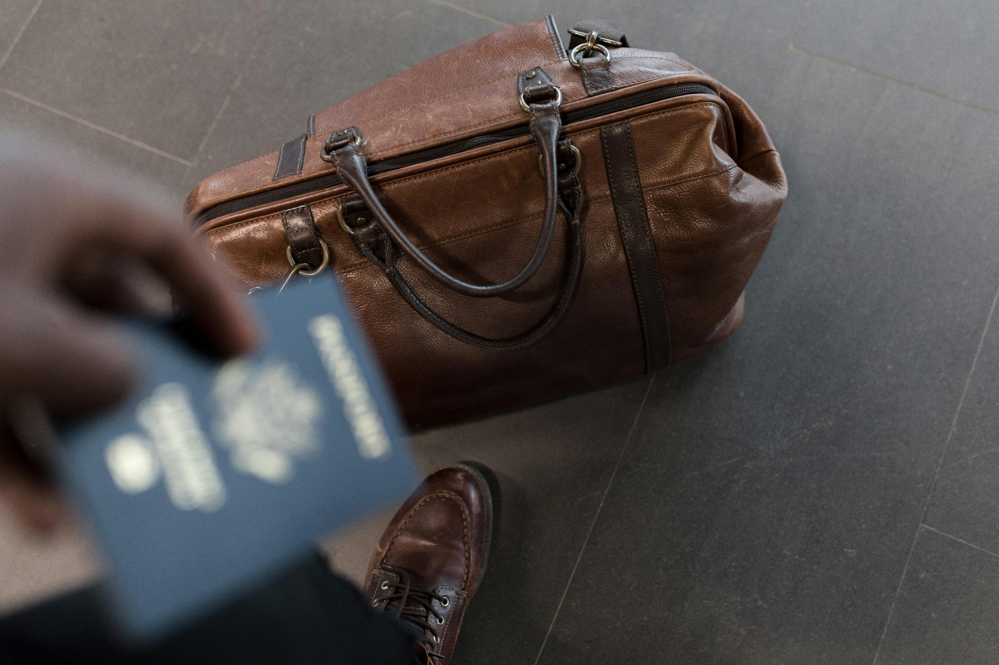

1. **Before Traveling**

* Secure Your Visa

- Ensure your visa is stamped in your passport before resigning from your Current job.

* Check Passport Validity.

- Verify your passport has at least 6 months of validity left.

- Secure all Soft SCANNED Copies of Important Documents in case of Document loss.

* Health Check-up

- Complete health check-ups (e.g., dentist) before moving as these may not be covered initially. Example Visting a Dentist is Super expensive..

* Insurance Coverage

- Confirm whether you need to purchase health insurance or if your employer provides it, and ensure it's effective from day one.

* Accommodation Contract

- Finalize and understand your housing contract to avoid surprises.

- Housing is a major issue in many countries starts well in Advance.

- Use the Official Website/App to safeguard from any Fraud.

* Indian Embassy Contact Details.

- Note the contact details of the Indian Embassy or Consulate in your destination country for assistance.

* International ROAMING Enabled SIM Card.
* Airtel Works well in Most of the A world Countries until you get a local SIM.

1. **Immediately After Landing**

* Local Apps (Commute, Medical, etc..)

- Download essential local apps for transportation, food delivery, and communication (e.g., Google Maps, Uber).

* Network Contacts

- Keep 2-3 local contact numbers from your network for emergencies and local advice.

* Forex Travel Card

- Use a forex travel card for initial expenses and currency exchange.

* International Transactions (Backup)

- Ensure your debit and credit cards are set up for international transactions.

* Emergency Contacts

- Local trusted contacts to share with your FAMILY.

1. **Within the First Month**

* Register with Local Authorities

- Complete necessary local registrations or paperwork (e.g., residence permits, local IDs).

* Health Insurance Enrollment

- Finalize and activate your health insurance coverage.

* Open a Local Bank Account

- Set up a local bank account for transactions and salary deposits.

Note: in a few countries opening account can take up to 45 days as well.

* Indian Food stores/restaurants
* It is quite easy to find Indian Grocery or Indian Restaurants.
* Cultural Adjustment

- Understand cultural norms and local laws to integrate smoothly.

1. **Ongoing**

* Stay Updated on Visa Requirements

- Monitor visa-related updates or renewals to avoid legal issues.

* Build Your Local Network

- Expand your local network for both professional and social support.

* Take care of TAX in India as well as the Country you traveled.

Connect with your CA for Indian TAX filing.

[Follow: For more latest updates](https://www.linkedin.com/in/abhishekpalpage/)

<https://www.linkedin.com/in/abhishekpalpage/>

**Happy Travel….**